Team RAMP Website and App Update
How Managers Can Access Their Team RAMP Account
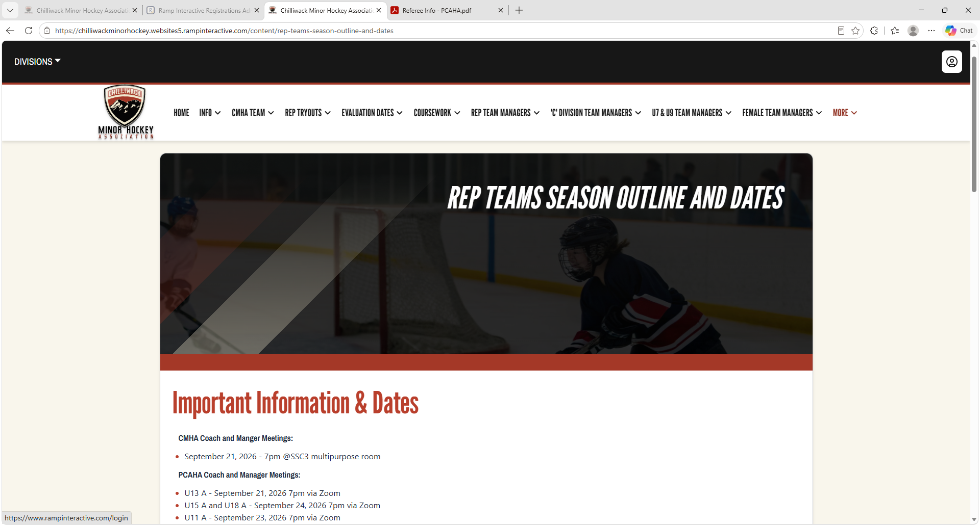
- Chilliwack Minor Hockey Association
- Click the person in the circle at the top right of the CMHA Website
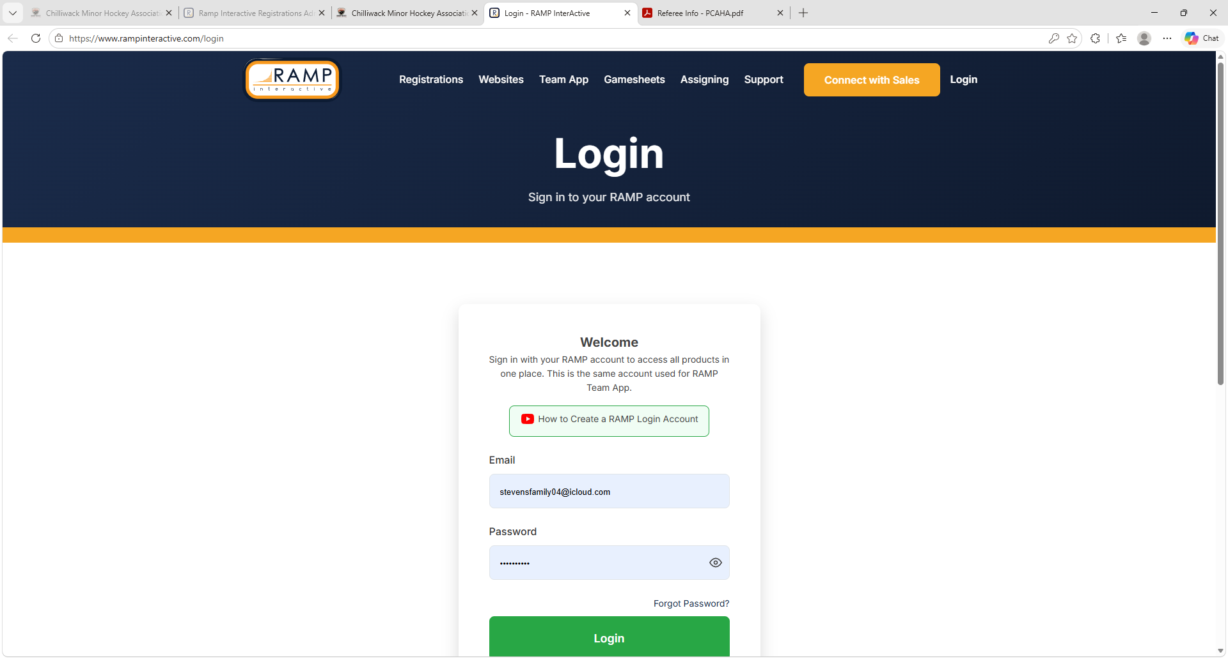
- Login using the email and password you use for your Ramp App account or create an account
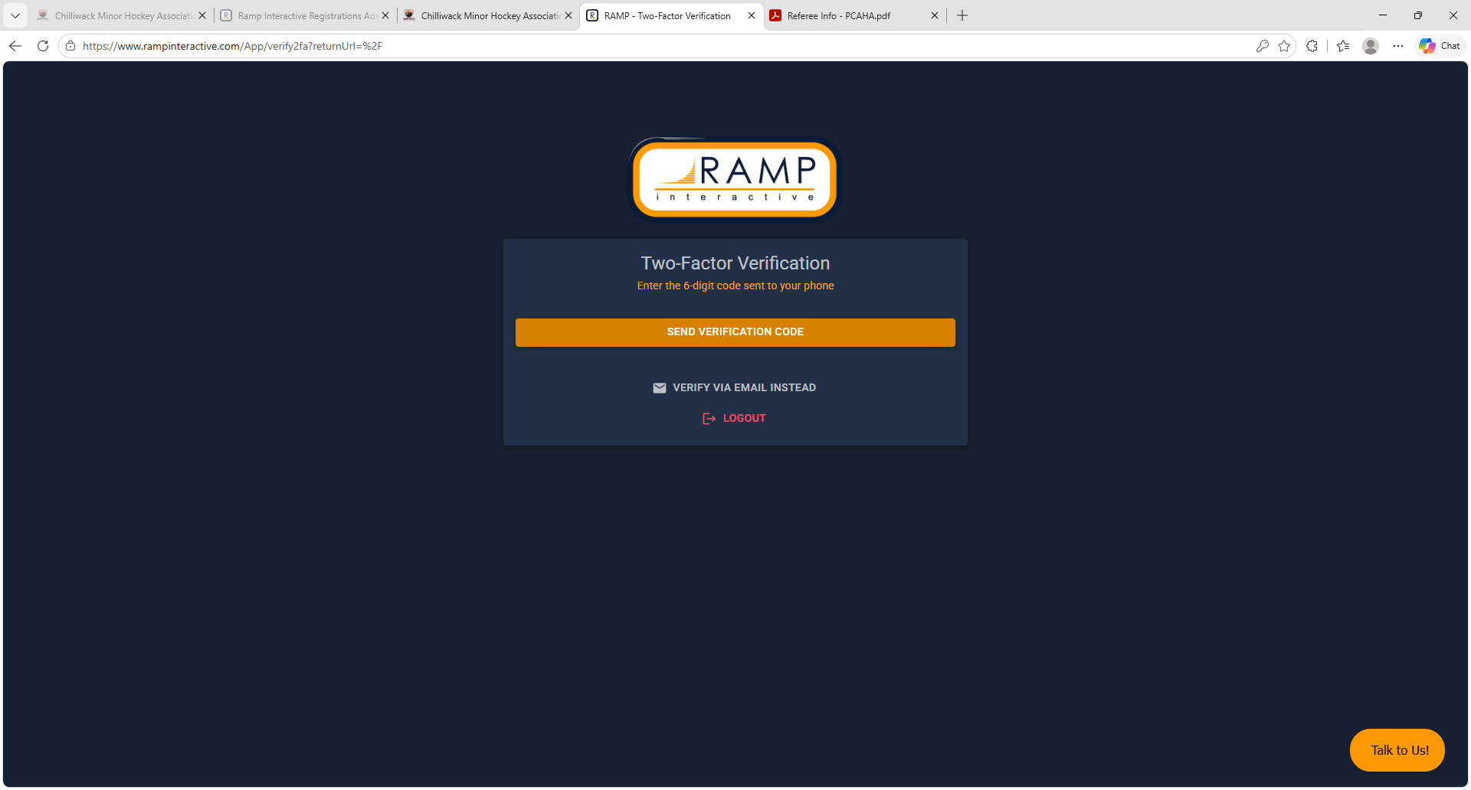
- Set up 2 factor verification – in this case it been set up already
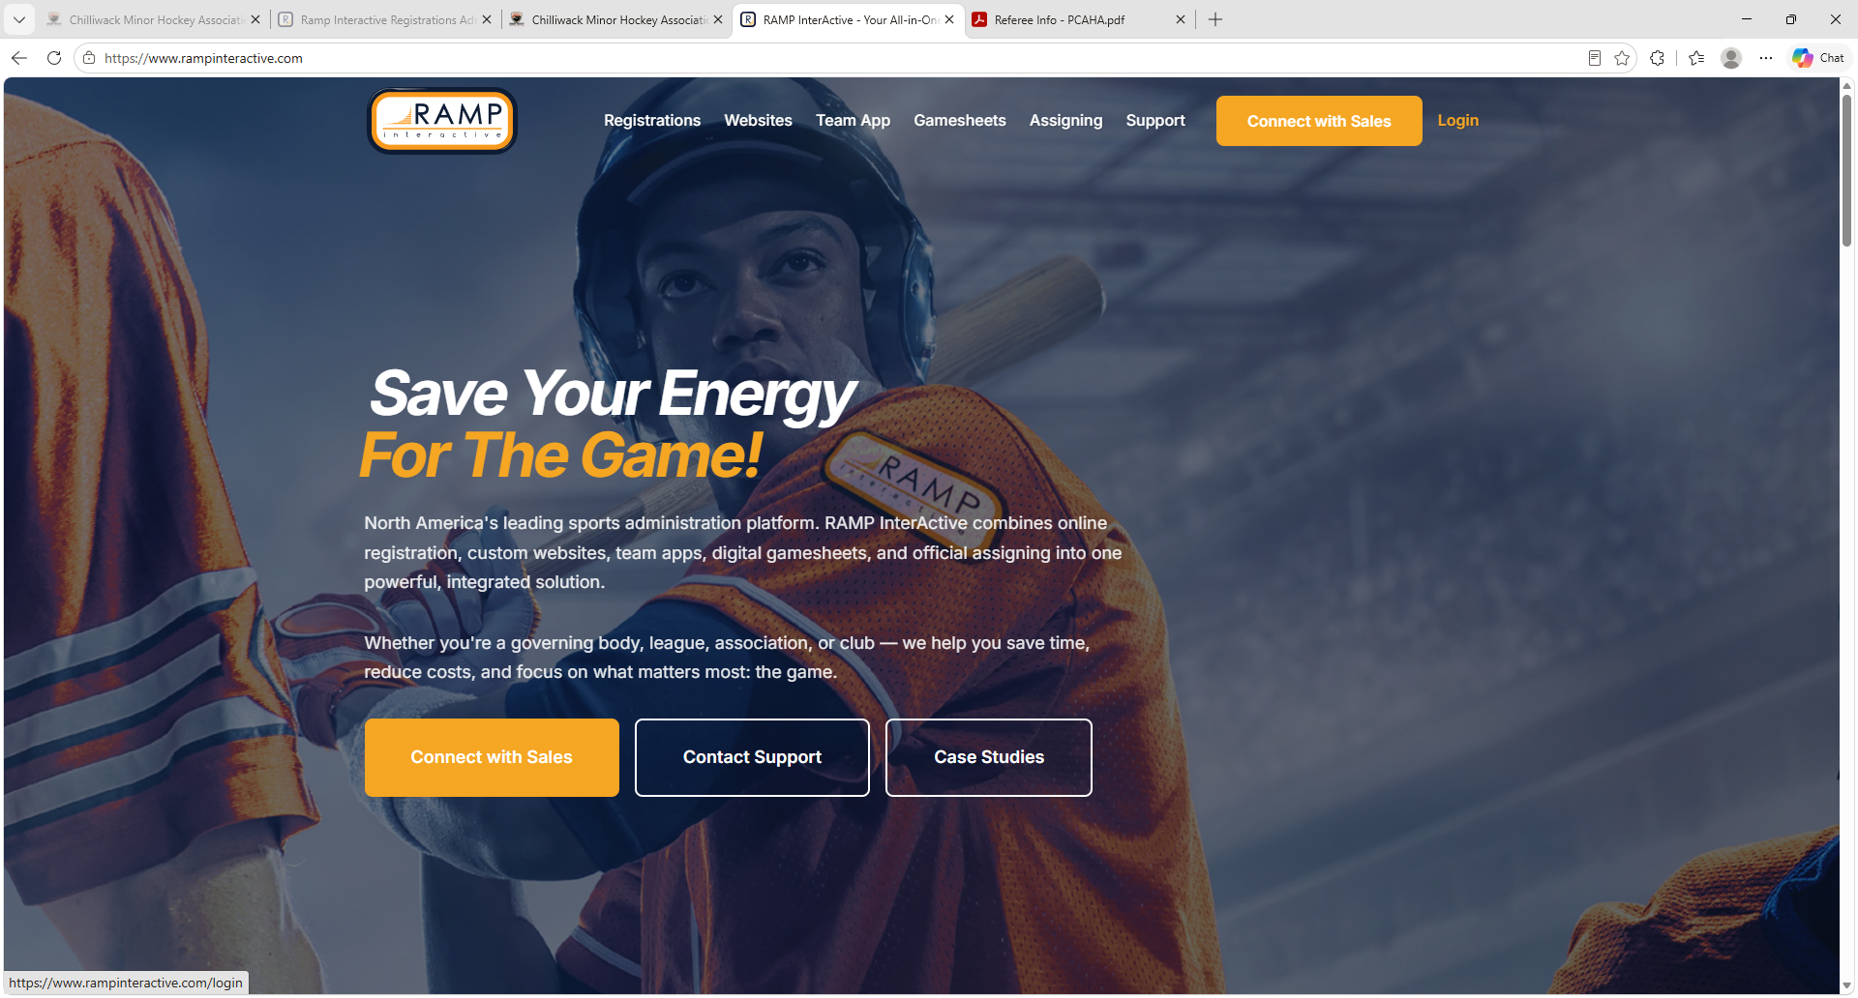
- If you get sent to this screen – click on the login on the top right of the screen

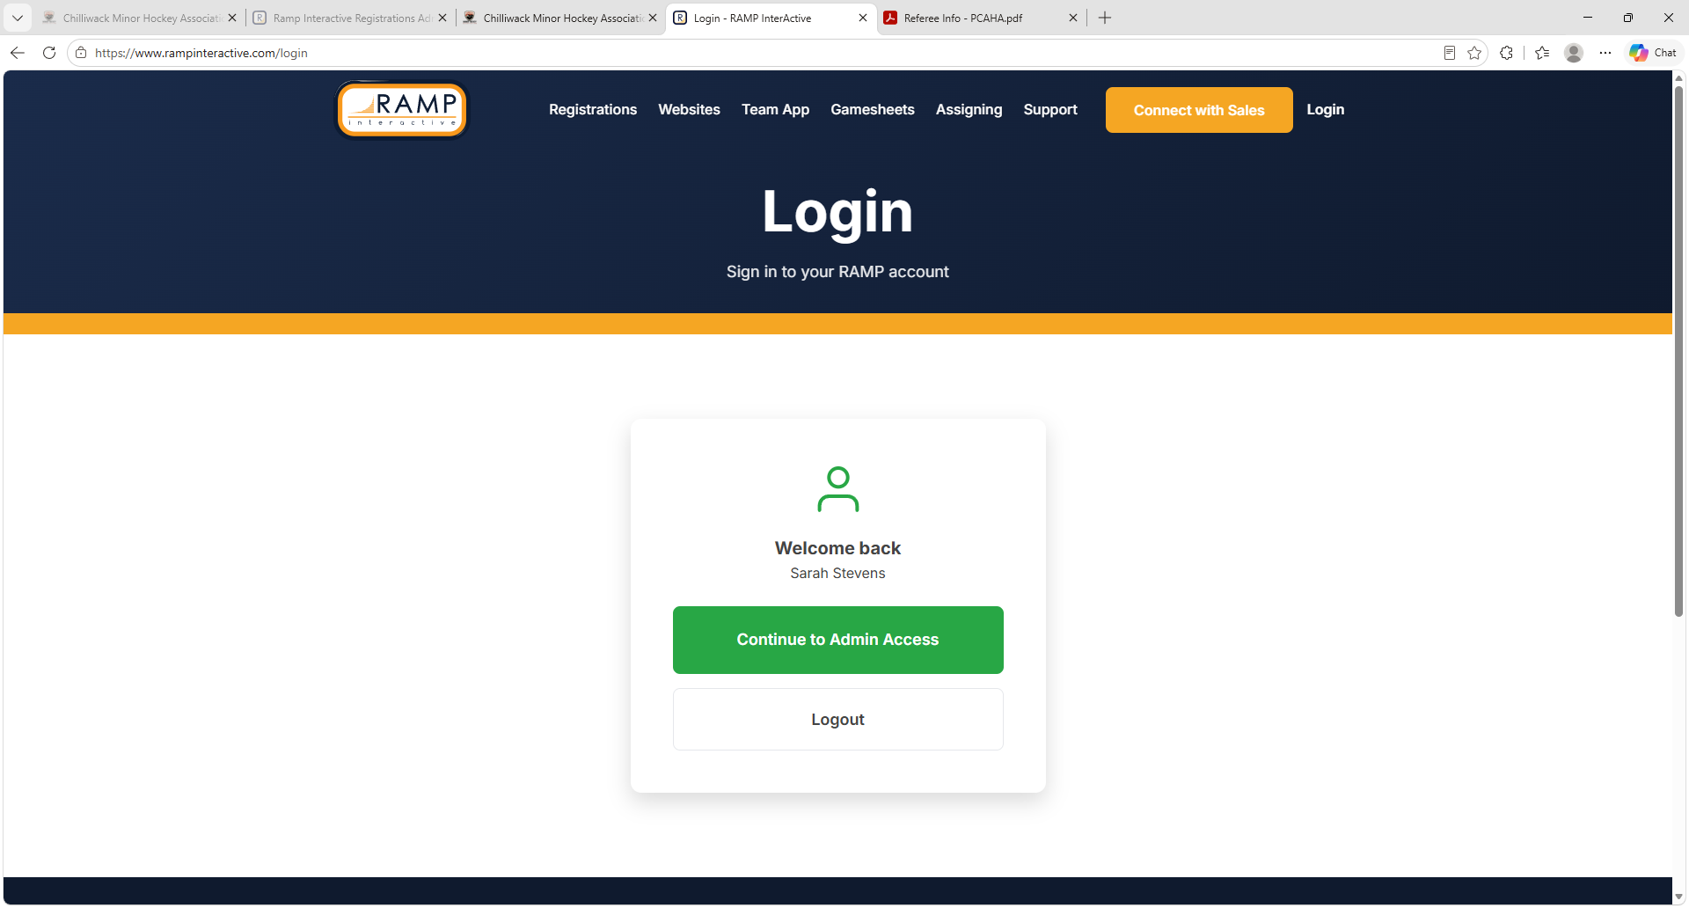
- Click Continue to Admin Access
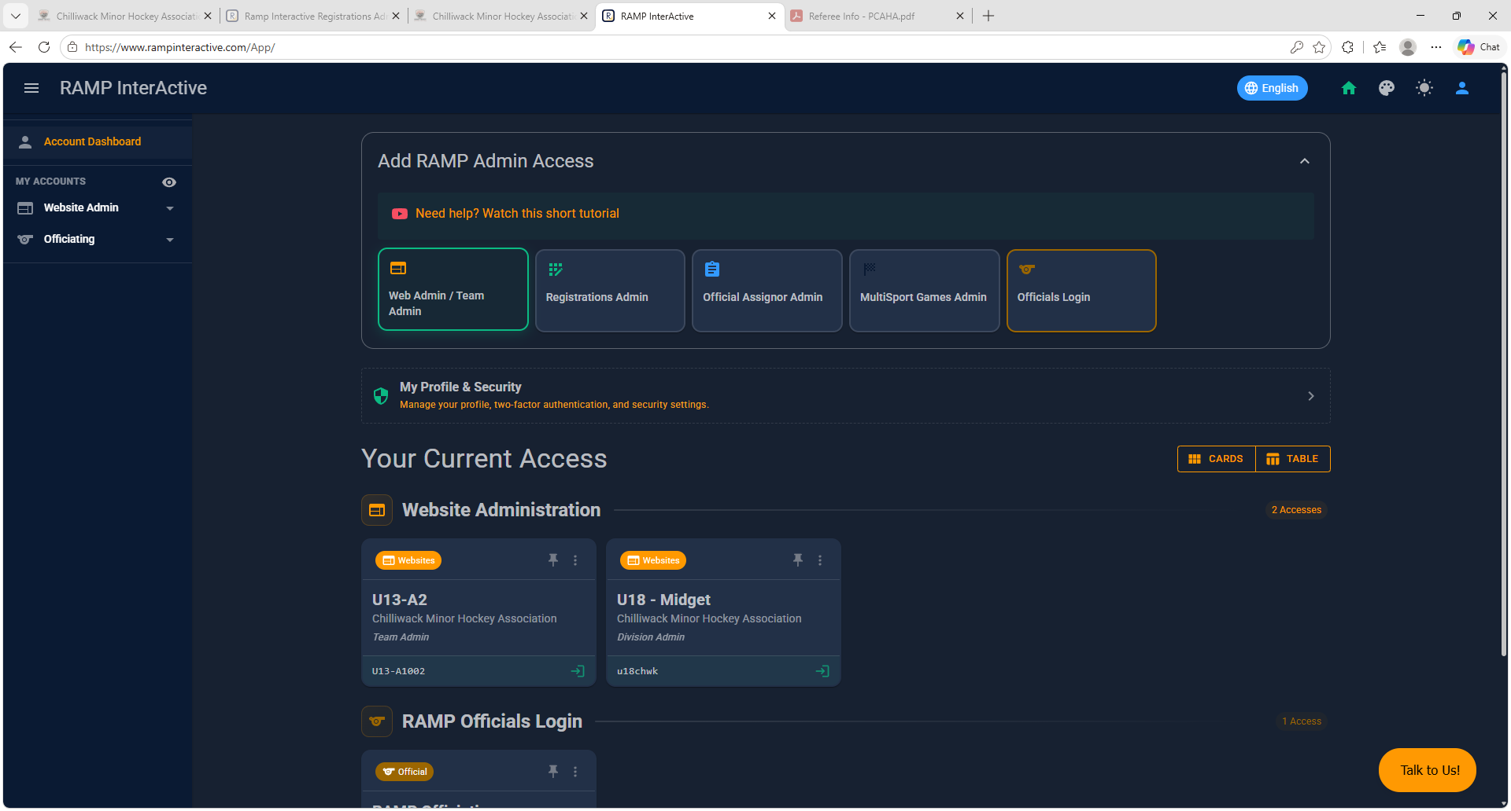
- You now have access to Ramp
- To add your team or teams if managing multiple - Click on the box called Web Admin Team Admin
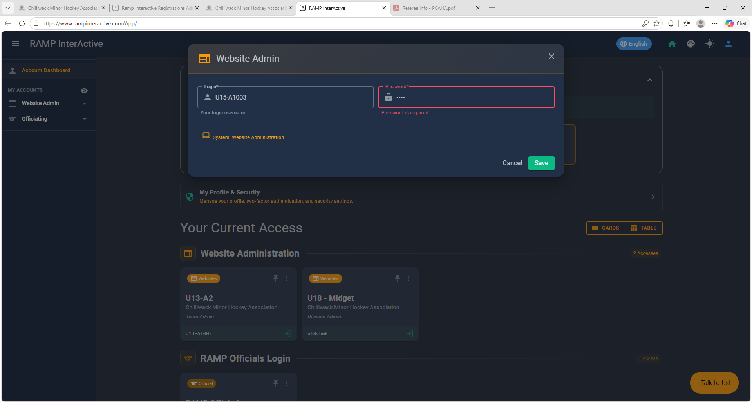
- Enter the team Username and Password you were provided by CMHA
- Click Save
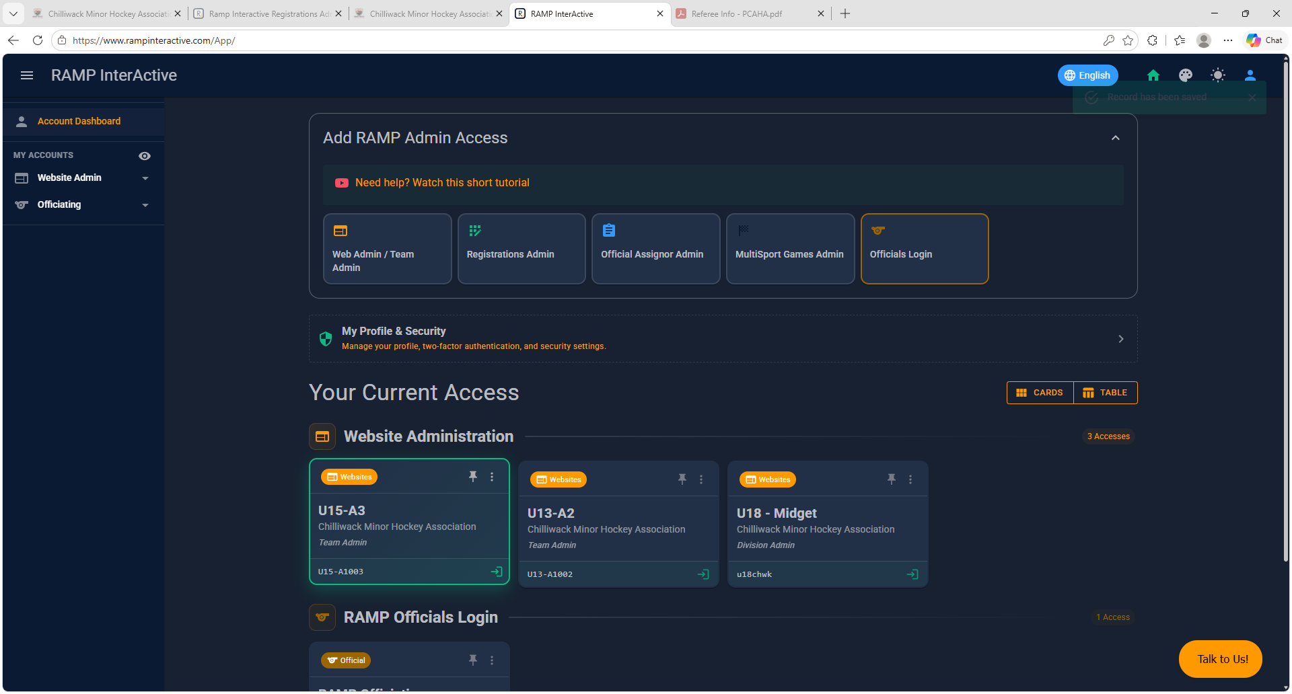
- You will now see the team or teams you have added and have access to as you can see above
- Click on the team you want access to – in this example we are clicking the U15 A3 team that’s high lighted green
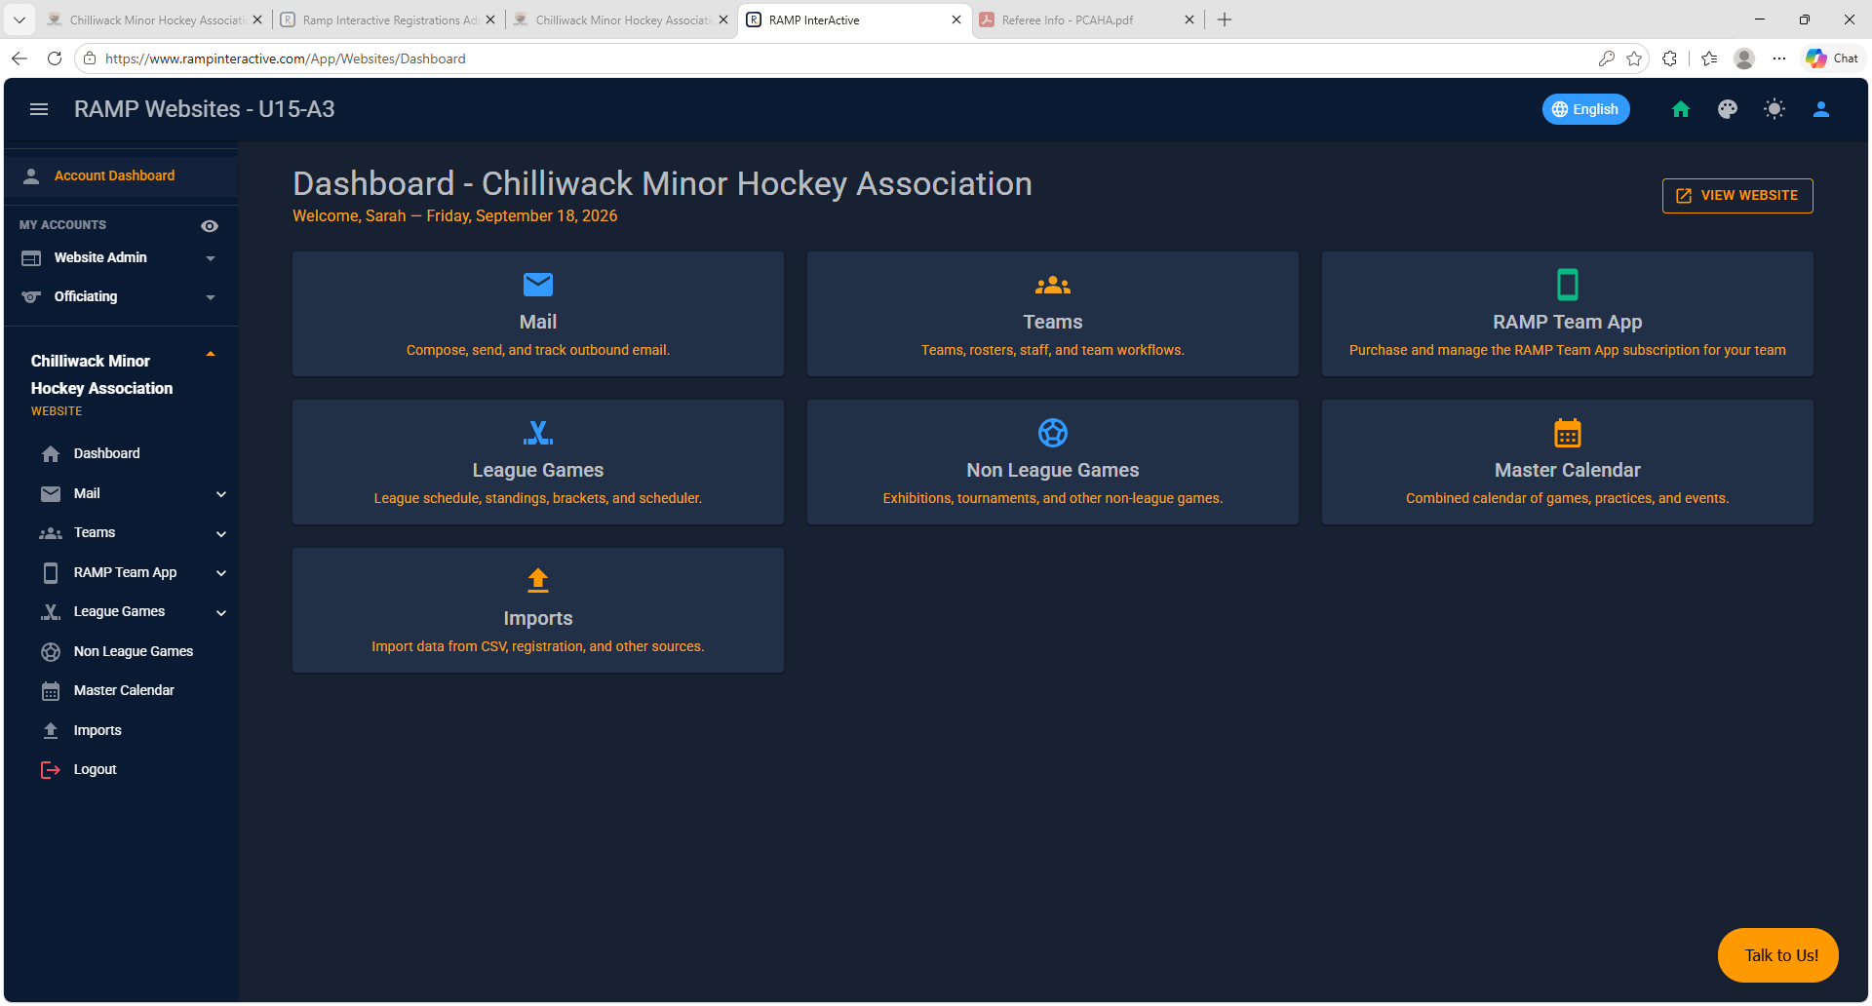
- From here you can navigate the main menu on the center of the screen or the menu bar from the left side of the screen
- Here you will enter your rosters with the player emails and send the Ramp Team App invites
- You can add your events, practices, and games
- Games will be added as non-league games
  - Select game type – league game, exhibition game, tournament game
  - Regardless of the game type selected, the app will display it as a non-league game.
    - I have Ramp looking into this to fix as it should show in the app the game type instead.

